**Experiment 27**

**Lab Book:**

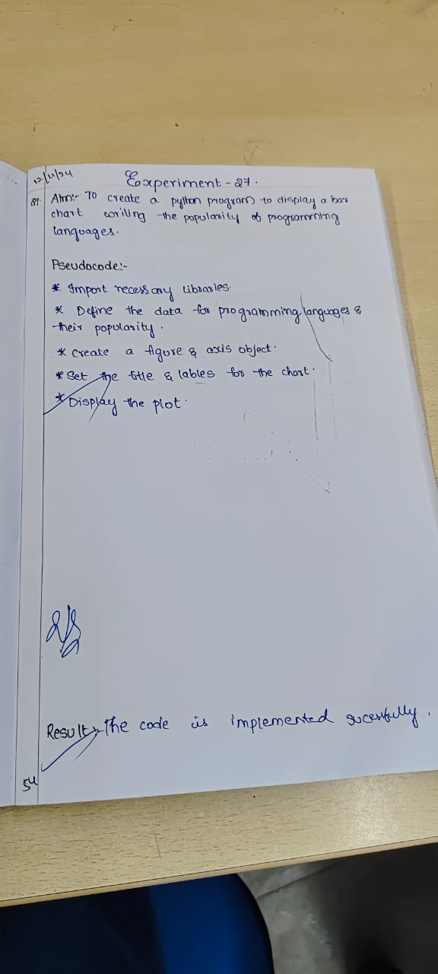

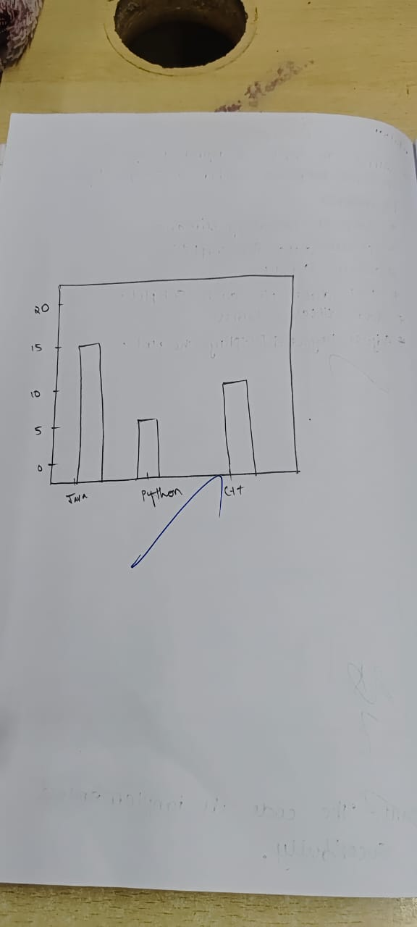

**Code**

import matplotlib.pyplot as plt

languages = ['Java', 'Python', 'PHP', 'JavaScript', 'C#', 'C++']

popularity = [22.2, 17.6, 8.8, 8, 7.7, 6.7]

plt.bar(languages, popularity, color='skyblue')

plt.xlabel('Programming Languages')

plt.ylabel('Popularity (%)')

plt.title('Popularity of Programming Languages')

plt.show()

**Sample Output**

